ENROLMENT OF FOUR NEW BROTHERS

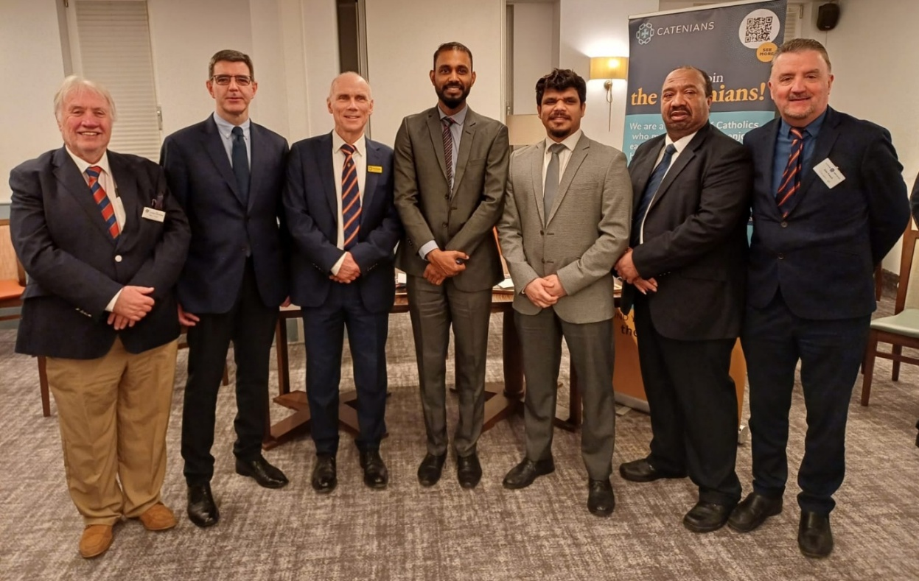

This photograph was taken of our newly enrolled brothers on 25th March 2025 after our Circle meeting at Purley Downs Golf Club. In the picture are, from left to right, Provincial Membership Officer Mike O’Neill, Justin Jordan, President Bernard Nelligan, Joy D’Souza, Stephan Buultjens, Michael Marshall and myself.

Justin Jordan was born in Ireland in 1971, He studied at University in London, joining Commercial Union (now Aviva) in Croydon, upon graduation in 1993, beginning an over thirty-year association with Croydon and Purley.

Justin married Ketsine in 2000. The couple have been blessed with two daughters - Gabrielle and Nicole. Ketsine and Justin have been parishioners at St John the Baptist, Purley for over 25 years.
After an over thirty-year career in finance and investment, Justin and Ketsine both retired in early 2025, to get involved in local volunteering and charity work. Ketsine and Justin are looking forward to developing new Catenian friendships in the future.

Justin’s sponsors were Andrew Denore and Noel Brownsell

Read below Joy D’Souza’s account of his journey in life:

“In November 2022, I stood at the threshold of a new chapter, my heart racing with anticipation as my family and I stepped onto UK soil. We did leave behind the familiar to chase opportunity, determined to weave a life of purpose through service and community. Settling in, I found my stride as a project management lecturer at a private institution, where sparking curiosity in young minds became my daily thrill. Meanwhile, my wife Janet donned her nursing uniform at St George’s University Hospital, her gentle hands healing patients and lifting spirits. Together, we poured ourselves into our callings, finding joy in every life touched.”

“By day, I navigate the exhilarating world of project management a decade of agile triumphs as a certified PMP® and PRINCE2® Practitioner fuelling my fire. Leading diverse teams through tangled challenges feels like conducting a symphony, every note of collaboration hitting the mark.”

“Faith and community are my roots. Once a youth president in my parish, I learned leadership amid laughter and chaos. Later, as diocese secretary, I honed a quiet resolve to serve. Now, at St. Dominic’s in Wadden, our family kneels in prayer, living our Catholic values with every step.”

“Outside of work and faith, football has been an integral part of my identity, the adrenaline pumping through my veins. This love for the game has taught me the art of building communities, sourcing, engaging, and collaborating with diverse individuals to create highly motivated teams.”

“In summary, my life is a tapestry of faith, service, and community, woven through my roles as a lecturer, project manager, family man, and football enthusiast. Joining the Catenians, felt like a natural extension of my life’s journey. It is not just a membership but a continuation of my mission to connect, support, and serve, making it a perfect fit for my values and aspirations.”

Joy’s sponsors were Gerry Gallen, Noel Brownsell and Stahl Fernandes

Stephan Buultjens originates from Sri Lanka, has lived and worked in multiple countries, including Dubai and is now settled in the UK. His background is in property management, and currently resides in Croydon with his wife, Aneeka.

Outside of work, he has a strong passion for travel, music, and exploring different cultures and enjoys meeting new people, experiencing diverse traditions, and embracing new opportunities. In his free time, he likes socializing, discovering new places, and spending quality time with family and friends.

He stated that “Joining the Croydon Circle has been a wonderful experience, and I look forward to building meaningful connections within the community”.

Stephan’s sponsors were Stahl Fernandes and Gerry Gallen.

Michael Marshall was born in East London within the sounds of Bow Bells and then lived his early years in North London. When he met and married Marilyn they moved to South London where they lived for several years, eventually moving to South Croydon in July 2017.

He’s had many different roles during his working career, starting in the Civil Service with the Department of Transport and Environment, then then Environment Agency. He’s currently in his 25th year working for Transport for London in Procurement.

He and Marilyn have been married for thirty-nine years. In his spare time he has fondness for gardening and DIY.

Michael’s sponsors were Terry McCarthy and Mike McFarlane

John Fennell
Membership Officer

