Chef’s Table

Croydon Circle’s very own ‘master chef’, Adelia Delicata, wife of Frank, treated a group of Catenians and their wives to a sumptuous feast on All Saints’ Day. We watched in awe as a few simple ingredients were skilfully transformed into tasty dishes which we eagerly sampled. Time saving tips were sprinkled liberally throughout the demonstration as were hints on how to ensure success with the trickier recipes.

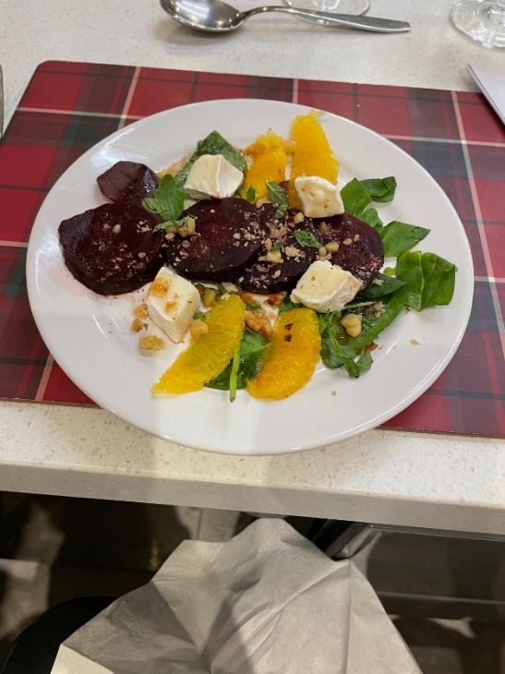
We knew that we were in for a treat when we were greeted with delicious canapés of home-made smoked salmon pate on ‘Ritz’ crackers and Bruschetta with Sundried Tomatoes and Mozzarella which accompanied the pre-dinner conviviality. Then it was time to sit down to watch Adelia demonstrate Beetroot and Orange Salad, a light and refreshing starter. (Top tip: grate the rind from the oranges before peeling them and freeze it ready to use in cakes and puddings.)

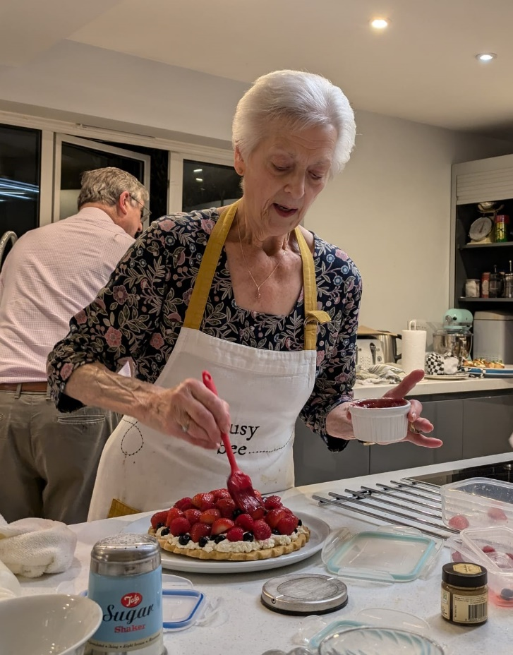
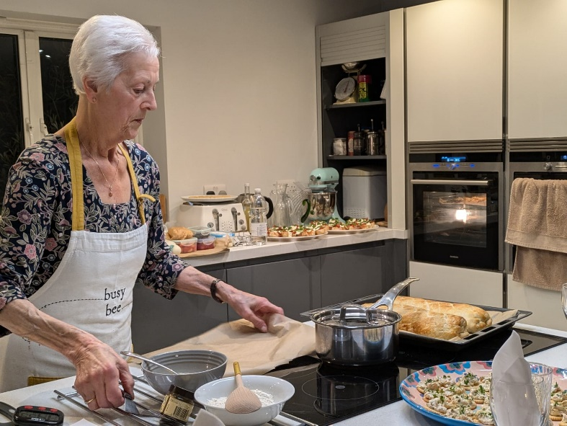
Two main courses followed: Chicken and Spinach En Croute in which cooked chicken, Parma ham, spinach and stuffing were enclosed in puff pastry. What a fabulous combination of flavours! (Top tip: an ideal recipe for Boxing Day when left over turkey can be used in place of the chicken and left-over stuffing too.). The second main was Baked Salmon with a Lime and Parmesan Crust. Both dishes were served with roasted new potatoes and a crisp and colourful salad.

We were ready then to sit back and watch Adelia prepare two desserts! An All-Season Open Fruit Tart consisting of a shortbread base topped with a mixture of Mascarpone, cream and vanilla and finished with a generous selection of colourful fruits. A range of alternative toppings were suggested e.g. fresh or canned pears with melted chocolate drizzled over. The second dessert was a nod to Adelia’s Italian heritage and devised by her 15 year old granddaughter: Tira Mi Choux Puffs – Choux balls filled with Tiramisu. These really were as sumptuous as they sound! We were shown how to make the Choux pastry balls and given several tips to ensure success.

We were provided with the recipes to take home.

The evening was hosted by Circle President Bernie Nelligan and his wife, Sue, who together with Adelia’s husband, Frank, served as sous chefs, waiters, sommeliers, washer ups and all round helpers. Huge thanks from all of us who enjoyed the evening to all of them.

The evening raised over £400 for the President’s charity.

Deirdre Geoghegan
November 2024
